Banks’ Florilegium original prints
- exclusively offered via the Friends of the Hocken Collections
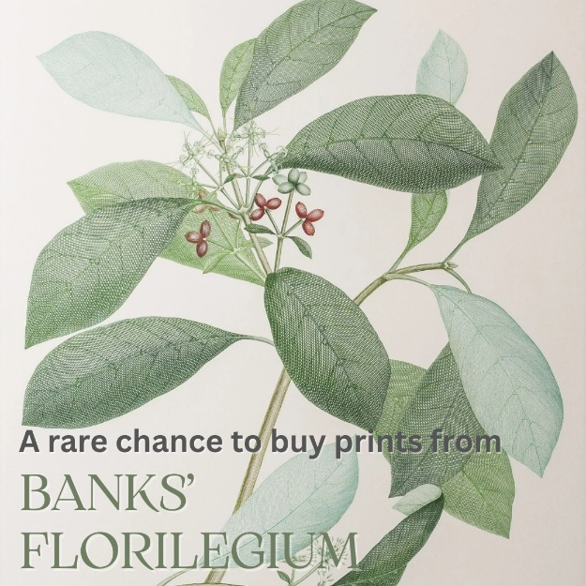
For the first time ever, individual prints from the notable Banks' Florilegium – a rare collection of engravings of plants collected by Sir Joseph Banks on Captain James Cook’s first voyage (1768 – 1771) round the world - are available to purchase.
The Friends of the Hocken Collections in Dunedin have been granted exclusive rights to sell single prints from this legacy collection of 743 colour prints (143 of which are New Zealand plants) previously only available as a complete set. The prints are limited editions – with never more than three prints of any plate and many of them having just a single print remaining.
The collection can be viewed and purchased on www.alecto-historical-editions.com, using the code - FOHC10 - to receive a 10% discount on each print. Every print purchased contributes 40% of the net sale price to the Friends of the Hocken Collections.
Chair Lorraine Isaacs says the opportunity to fundraise by giving individuals the opportunity – for the first time ever – to purchase single prints from the Banks' Florilegium is an incredible honour.
“The Hocken purchased a full collection in the 1980s, so those who appreciate botanical prints have been able to view this collection on request, but to be able to own a piece of history like this is a marvellous offer.”
“And for us, the more people purchase, the more funds we will have to support projects like our regular Friends of the Hocken Collections Award.”
“But it also means that individuals can have these beautiful botanical prints of their choosing in their own homes. It truly is an extremely rare offer, which we are very glad to share with our community.”
The Friends of the Hocken Collections will have several collection prints available for viewing. Please contact Lorraine Isaacs if you would like to view a print.
For more information contact: The Friends of the Hocken Collections - Banks' Florilegium subcommittee Chair, Lorraine Isaacs ph: 021 023 62423

Background Information
Banks' Florilegium comprises the 743 botanical engravings of plants collected by Sir Joseph Banks and Dr Daniel Carl Solander in Madeira, Brazil, Tierra del Fuego, the Society Islands, New Zealand, Australia and Java on Captain James Cook’s first voyage round the world in His Majesty’s barque Endeavour.
On his return to London in 1771, Banks determined to publish a grand scientific record of his botanical collection. Over thirteen years, while Daniel Solander prepared the accompanying botanical texts, Banks employed five artists to complete the field sketches drawn on board ship from the fresh specimens by Sydney Parkinson, and eighteen engravers to create exquisite copper plate line engravings from the drawings. All the plants included in Banks’ Florilegium were new to European botany. By 1784 all of the plates had been completed but, for a variety of reasons, Banks delayed publication.
On his death in 1820, having served as President of the Royal Society for forty years and recognized as the great panjandrum of European science, Banks bequeathed his library and herbarium, together with the Florilegium plates, to the British Museum. A hundred and sixty years later the unpublished plates were to be found, encased in their eighteenth-century wrappers, in a cupboard in the Botany Library of the Natural History Museum in London.
The engravings were printed and published for the first time in colour between 1980 and 1990 by Alecto Historical Editions, in association with the British Museum (Natural History), in a limited edition.
Some images are out of stock and there are never more than three prints of any particular plate. The Natural History Museum and Alecto Historical Editions published what became the largest printing project of the 20th century.

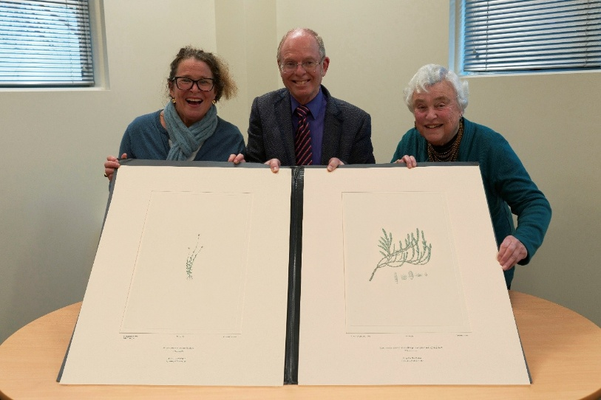
Friends of the Hocken Collections - Banks' Florilegium subcommittee:
Left to Right: Becs Wilson, Mark Hughes, Chair - Lorraine Isaacs

